MTTQ   
Architecture and Design Specification

Author:

TCS

# Approval Signatures

This template is designed to accommodate digital signatures. The use of digital signatures is not mandatory; however, it is mandatory that all signatories of this project deliverable use the same method of signing (digital signature OR handwritten signature).

This project deliverable may be signed digitally. If digital signatures are used, they will be attached to the end of this document and this section will identify the names, roles and intent of the signatories. Otherwise, handwritten signatures will also be included in this section.

|  |
| --- |
| Signatures |

|  |  |
| --- | --- |
| I have authored this deliverable to document the architecture and design specifications for mytimetoquit.com.au | |
| TCS DEV TEAM | 21/04/16 |

QA signatures may be required based on compliance risk.

|  |  |
| --- | --- |
| I have reviewed the content of this record and found that it meets the applicable compliance requirements. | |
| <Name>, BT QA | DD-MMM-YYYY |
| <Name>, BU QA | DD-MMM-YYYY |

**Table of Contents**

Contents

1. Approval Signatures 2

2. Introduction 5

2.1 Purpose 5

2.2 Scope 5

3. Architectural Goal 6

3.1 Architectural Overview 6

3.1.1 Capability Roadmap and Technology Strategies 6

3.1.2 Overview 6

3.1.3 3rd Party vendors 13

3.2 Architecture Configurability 14

4. Architecture Quality & Alignment 14

4.1 Development Guidelines 14

4.2 Repeatable Patterns 14

4.2.1 Language translation and localization 14

4.2.2 Vendor Ids for the 3rd party vendors 15

4.2.3 Other admin interfaces to configure 15

4.2.4 SOA Services 15

4.3 Master Data Management: Data Types 15

4.4 Architecture Exceptions 15

5. Architecturally Significant Design Packages 15

6. Database Schemas 15

7. Deployment View 15

8. Implementation View 15

8.1 Overview 15

8.2 Layers 15

8.2.1 Client Tier 16

8.2.2 Presentation Layer 16

8.2.3 Control Layer 16

8.2.4 Business Logic Layer 16

8.2.5 Data Access Layer 16

8.2.6 Enterprise Information Layer 16

9. System Design 16

10. Directory Structure 16

11. File Naming Conventions 16

12. Development Technologies 16

13. Conversion Design 17

14. System Interface Design 17

14.1.1 Interface Technical Requirements 17

15. Security Design 18

16. System Components 18

16.1.1 Overview 18

16.1.2 Minimum Configuration Requirements 18

16.1.3 Processing 18

16.1.4 Outputs 18

16.1.5 Implications for Business Process/Operations 18

17. Source Code Compiling and Linking 18

18. Supporting References 18

19. Revision History 19

20. Appendices 19

# Introduction

This documentation is intended to capture architecture and design specification for MTTQ website. This document will serve as the main input to the development and testing activities of the project. The document will be managed by the Development Leads with support from the Architects.

## Purpose

This documentation is intended to capture architecture and design specification for MTTQ website. It outlines the steps required to build the components necessary to commence development activities on the functionality described in section 2.2 titled “Scope” of this document. The audiences for this document are those individuals who need to approve the design to ensure compliance to Pfizer’s technology and architecture guidelines.

## Scope

The scope of this document is to provide the architectural details of the MTTQ applications in terms of different views. The different level views include the following

* Presentation Architecture View explains the Presentation Layer of the application.
* Business level view which explains the implementation of back-end business logic
* Information level view gives details about the data flow and data storage.
* Infrastructure view gives details about the physical components involved.

# Architectural Goal

The website is intended for Champix brand. This helps patient to quit the smoking habits.

Patients can register themselves/Medical director/through Guildcare and they could see their journey till 100% nicotine free day.

The application follows up with patient via Email/SMS to help the patient till their nicotine free journey.

## Architectural Overview

### Capability Roadmap and Technology Strategies

The website would be built on the custom drupal platform. The version of Drupal is 7.

### Overview

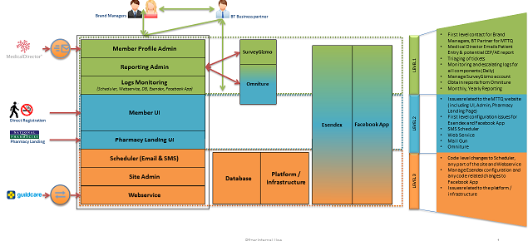

Figure 1: Overview of the project

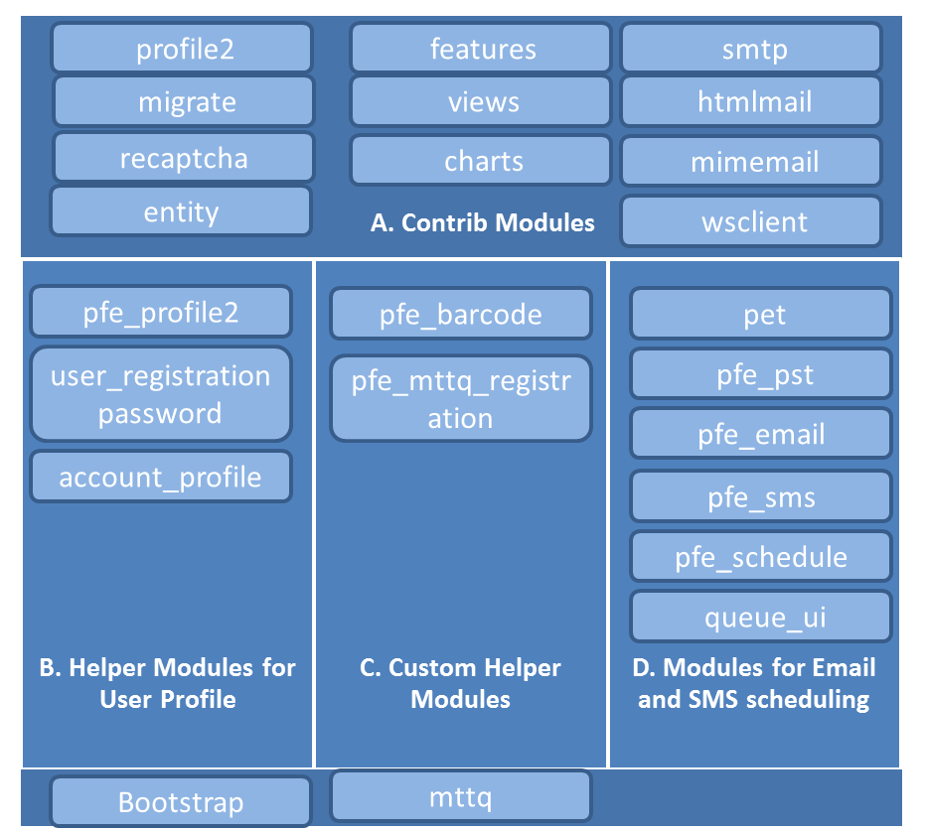

Figure 2: Architectural Overview – Custom Drupal Website

**Website Visitors**

Visitors can register to the nicotine free program with valid barcode. Upon validation user will prompt to fill the basic information along with Smoking information ie. Smoking start year, total number of Cigs smoke per day etc. Upon completion user will receive an activation email through which he can successfully enroll to the program.

My Progress

The my progress page captures and shows patient journey

My Champix

My champix page shows patient journey.

**Custom Modules**

* Pfe_barcode: Module implements Barcode validation functionality to registration page. The barcodes are predefined in the system under barcode content type.
* Pfe_email: Creates listing of all week quitter. And uses preview able email template module.
* Pfe_mttq_migrate: migrating users from .net to drupal environment.
* Pfe_mttq_registration: Add all the registration related functionality.
* Pfe_pst: For creating replica of PET(Preview able email template) for SMS template.
* pfe_profile2: This module provides multistep user registration form.
* Pfe_schedule: Has cron job which will run to send sms and email on daily basis.

|  |  |
| --- | --- |
|  | * Pfe_sms Creates listing of all week quitters. Uses PST module. |
|  | * Pfe_unsubscribe: Module has an unsubscribe form which is used to unsubscribe users from email and sms scheduler. * Pfmytimetoquitau_progress: Creates a My Progress page. * Create table "pfe_profile_metadata" to store profile related data and "pfe_smoking_survey" to store smoking details. My progress page has 8 widgets. |
|  | **MyProgress Page:** |

As per PFZ1055_MTTQ_Functional_Specification_v1.4.pdf(Provided in KT document) (PN - 31)



* **Widget a** - Created using custom code.
* **Widget b** - Created using https://google-developers.appspot.com/chart/interactive/docs/gallery/columnchart. Data is saved by ajax call.
* **Widget c** - Created using views (health_benefits) and jquery cycle plugin.
* **Widget d** - Calculated using code and data saved from widget b. Calculation logic is as per
* **Widget e** - Created using views (my_champix1).
* **Widget f** - Data populated from vocabulary "reasons_to_quit". Data stored in session using ajax call.
* **Widget g** - Created using https://google-developers.appspot.com/chart/interactive/docs/gallery/barchart. Data used from "pfe_profile_metadata" table
* **Widget i** - Created using Facebook API's. "Feed", "GET" methods used for achieving functionality. An app created for this with scope "publish_actions" and "email". When user shares the post its post_id is saved in database table "pfe_profile_metadata". User can share only one time.

**My Champix page:**

This page shows the current step of the patient and Tips.

**Key features**

* **User registrations**

There are 4 entry points through which user can register,

1. **Direct user registration-**

User enters a valid Barcode, and proceeds for the registration.

The custom module is created to achieve this functionality, **pfe_mttq_registration**

1) This module is mainly created to customize the registration flow and changes as per user requirement.

2) Altered the user registration fields and profile2 fields as per the requirement and functionality using form_alter and form_id_alter hooks.

3) Handled registration validation and customized error messages.

4) Handled the redirection for anonymous users.

5) Added, Updated, Deleted user information in pfe_profile_metadata table using profile hooks.

6) "Connect with Facebook" functionality is done using Facebook JavaScript SDK in js/general.js file.

Facebook credentials: [Tcsdrupalteam@gmail.com/](mailto:Tcsdrupalteam@gmail.com/) tcs_1234

*NOTE: To retrieve user's birthday from facebook, we have submitted the facebook APP for review. Review is not required for the three basic permissions: "public_profile, user_friends and email", but fb review is require to fetch "user_birthday" from users basic information.*

[*https://developers.facebook.com/docs/facebook-login/review/what-is-login-review*](https://developers.facebook.com/docs/facebook-login/review/what-is-login-review)

1. **MD user registration**- Separate login is provided to the MD user. They can add Users to the website.



1. **National pharmacy registration-** There is a separate landing page provided for National pharmacies. Wherein, patient can approach to the pharmacy, pharmacy may have list of barcodes through which they can register a user (same as of direct registration). [www.mytimetoquit.com.au/nationalpharmacies](http://www.mytimetoquit.com.au/nationalpharmacies)
2. **GuildCare registration-** User registration through guildcare scheduler jobs, which triggers an end point on mttq website to register the user.

*Ps: Not to remove user role, "GuildCare Service” and user account* [*guildcare@test.com*](mailto:guildcare@test.com)

*from dev, stg, prod environment. This is being used to validate the webservice.*



* **User Migration**

User migration of ~35,000 users is performed from .net => Drupal

Data from below tables was provided for the migration purpose,

- Member

- MemberRegistrationProfile

- RegistrationProfileCategory

- RegistrationProfileItem

- MemberProfile

Custom module, **pfe_mttq_migrate** is created to achieve the functionality.

1) This module does the functionality of migrating users from csv file to db.

2) Three classes are created. "MTTQUserMigration" is to create drupal user account. "MTTQ_Step1_UserProfileMigration" will migrate step1 profile field data. "MTTQ_Step2_UserProfileMigration" will migrate a step2 profile field data.

3) Mapping is done in the classes for csv columns with the associative drupal fields.

Steps are as per attached document.



* **Email and SMS scheduler**

Emails and SMS are configured into the website. Once the cron job runs, the scheduler will generate the email/sms that needs to be sent to the users.

The website uses mailgun for Emails and Esendex for SMS delivery.

 Esendex details,

URL: <http://www.esendex.com.au/>

Username: servicedelivery.australia@pfizer.com

Password: pfizer

Account               : EX0088481

Description         : MTTQ - Live

Number               : 61416906359

Account               : EX0089486

Description         : MTTQ - Test

Number               : 61416906366

*NOTE: test environment is no more active. SMS will not be triggered out of test environment.*

pfe_schedule: This module takes care of pulling set of SMS candidates from pfe_profile-metadata table from Drupal database and Configuring SMS Schedule for Champix and Quit Specific Non – interactive (scheduled at 10am AEDT) and Interactive SMS (scheduled at 10:30am AEDT)

* WSDL SOAP Request from Drupal to Esendex to Send SMS Text, Recipient Number and Format (i.e. Text)
* Esendex Sends SMS to End User
* As soon attempt to send SMS done by Esendex, Esendex does sends Push notifications for Delivered (Outbound), Failed, Received (Inbound)
* User Can reply back to SMS for Unsubscribe by sending STOP/Y/N, based on last SMS is interactive or non-interactive and reply received Drupal classify users SMS Reply as Valid/Invalid
* pfe_sms module takes care of logging Push notifications replies received from Esendex for Delivered (i.e. Outgoing), Failed and Incoming (i.e. Inbound)
* Esendex: Esendex acts as 3rd Party layer for SMS Communication between Drupal and End User.

*PS: the template should be in <tr> <td> format. Do not change the HTML structure of any template unless it is specifically mentioned to alter the layout.*

* **Logs Monitoring**

SMS logs can be monitored at,

URL: <http://www.esendex.com.au/>

Username: servicedelivery.australia@pfizer.com

Password: pfizer

Email logs can be monitored at,

<https://mytimetoquit.com.au/admin/report/email-transaction>

Also, mail gun logs can be verified by raising ticket to **DL-BT-DIGITALMARKETING**.

* **Admin Reporting**

1. **User Reporting** captures detailed information of registered users.
2. **Outbound SMS** reporting generates the report that captures outbound SMS that are sent from the system
3. **Inbound SMS** reporting Generates the report that captures Inbound SMS ie. SMS for which reply has been received by the system.
4. **Omniture** reporting Omniture is web analytic tool that captures analytics of page visits.



* **Admin section**

Below is a list of Content that is editable from Admin region.

1. User journey steps
2. Health benefits text
3. Reward Messages
4. Cost per cig
5. Reasons for quitting
6. FB twitter sharable text
7. Champix Dosage information



### 3rd Party vendors

**Esendex:**

URL: <http://www.esendex.com.au/>

Username: servicedelivery.australia@pfizer.com

Password: pfizer

Account               : EX0088481

Description         : MTTQ - Live

Number               : 61416906359

Account               : EX0089486

Description         : MTTQ - Test

Number               : 61416906366

**Guildcare**

Webservice is created at drupal end, which is being called from Guildcare scheduler.

<http://www.mytimetoquit.com.au/mttq/guildcare/register/profile2/create.json>

**Facebook**

https://developers.facebook.com

Facebook application is created for Dev stg and production environment.

[Tcsdrupalteam@gmail.com/](mailto:Tcsdrupalteam@gmail.com/) tcs_1234

FB app dev: 798226423637731

FB app stg: 798226900304350

FB app prod: 798212813639092

## Architecture Configurability

Solution will consist on some Drupal custom, contributed modules and javascript files.

# Architecture Quality & Alignment

## Development Guidelines

Development will follow Drupal Best Practices <http://drupal.org/best-practices>

## Repeatable Patterns

The application built for US will be configurable to migrate to different region or different Brand for similar reminder pattern. In different region, the vendor’s configuration needs to be done separately.

### Language translation and localization

NA

### Vendor Ids for the 3rd party vendors

3rd Party Pharmacy Vendors will be identified with a unique Vendor Id.

### Other admin interfaces to configure

NA

### SOA Services

NA

## Master Data Management: Data Types

NA

## Architecture Exceptions

*NA*

# Architecturally Significant Design Packages

NA

# Database Schemas

NA

# Deployment View

The solution will be deployed into the Drupal platform of Acquia.

# Implementation View

## Overview

*NA*

## Layers

*NA*

### Client Tier

*NA*

### Presentation Layer

*NA*

### Control Layer

*NA*

### Business Logic Layer

*NA*

### Data Access Layer

*NA*

### Enterprise Information Layer

*NA*

# System Design

*NA*

# Directory Structure

*NA*

# File Naming Conventions

| **Design Item** | **Naming Convention** | **Description** |
| --- | --- | --- |
| *NA* |  |  |

# Development Technologies

| **Application** | **Tool, System, Database,**  **Platform, Etc.** | **Comments** |
| --- | --- | --- |
| Application Development | Drupal |  |
| Browser | IE8+, Firefox 3.5+, Chrome 26+, Safari 5+ |  |
| Business Rules | NA |  |
| Client Server Architecture | NA |  |
| Database | NA |  |
| Database Access | NA |  |
| Database OS Platform | NA |  |
| Security | NA |  |
| Software Version Control | Git |  |

# Conversion Design

Source Databases: NA

* Source Elements: NA
* Validation Rules: NA
* Processing Rules: NA
* Conversion Component: NA
* Conversion Contingency Arrangements: NA
* Reporting Controls: NA
* Data Security: NA

# System Interface Design

### Interface Technical Requirements

| **Interface Technical Requirements** | | |
| --- | --- | --- |
| *<Technical Requirements ID>* | NA | |
| **Hardware Interfaces** | | |
| Hardware Devices | | NA |
| Supporting Devices | | NA |
| **Software Interfaces** | | |
| Name | | Drupal |
| Specification Number | | NA |
| Version Number | | 7 |
| **Communications Interfaces** | | |
| Protocols | | HTTP/ HTTPS for interfaces |
| **Data Interfaces** | | |
| Data processing | | NA |
| Backup and Recovery | | Github repository will ensure timely Backup and Recovery |

# Security Design

The design will ensure that the Web Services built will exchange data over secured protocols. Also while building functionalities using custom code the best practice of sanitizing user input via Drupal core functions check_plain() and filter_xss() and/or PHP htmlspecialchars() will be used.

# System Components

### Overview

NA

### Minimum Configuration Requirements

NA

### Processing

| **File Name** | **Functional Description** | **Location** | **Inputs/Outputs** |
| --- | --- | --- | --- |
| NA |  |  |  |

### Outputs

NA

### Implications for Business Process/Operations

NA

# Source Code Compiling and Linking

The source code will be loaded to the Acquia environments using the GIT repository

# Supporting References

*NA*

| **Record Number** | **Reference Title** |
| --- | --- |
|  |  |

# Revision History

| **Version** | **Author** | **Date** | **Revisions** |
| --- | --- | --- | --- |
| 1.0 | Dakshayani C | 21st April 2016 | Initial Draft |

# Appendices

| **Appendix** | **Appendix Name** |
| --- | --- |
|  |  |

|  |  |
| --- | --- |
|  |  |
|  |  |